Ultimate Guard Display: Floor

Ordering Process
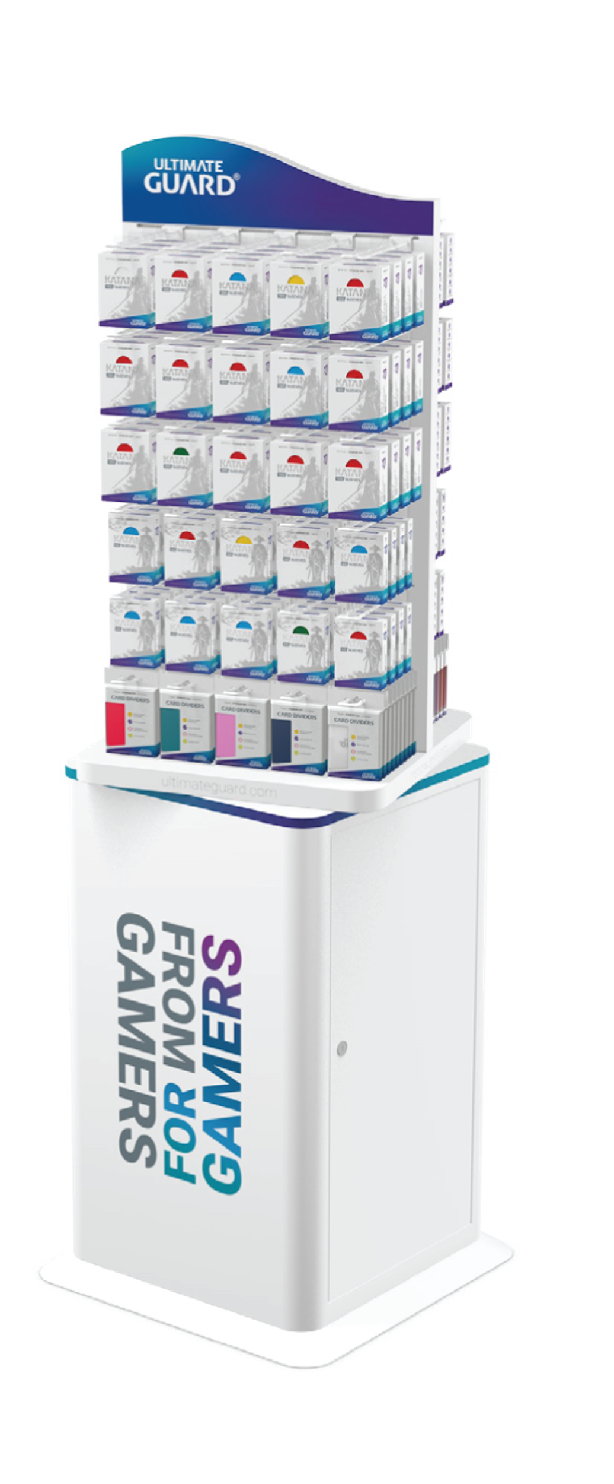
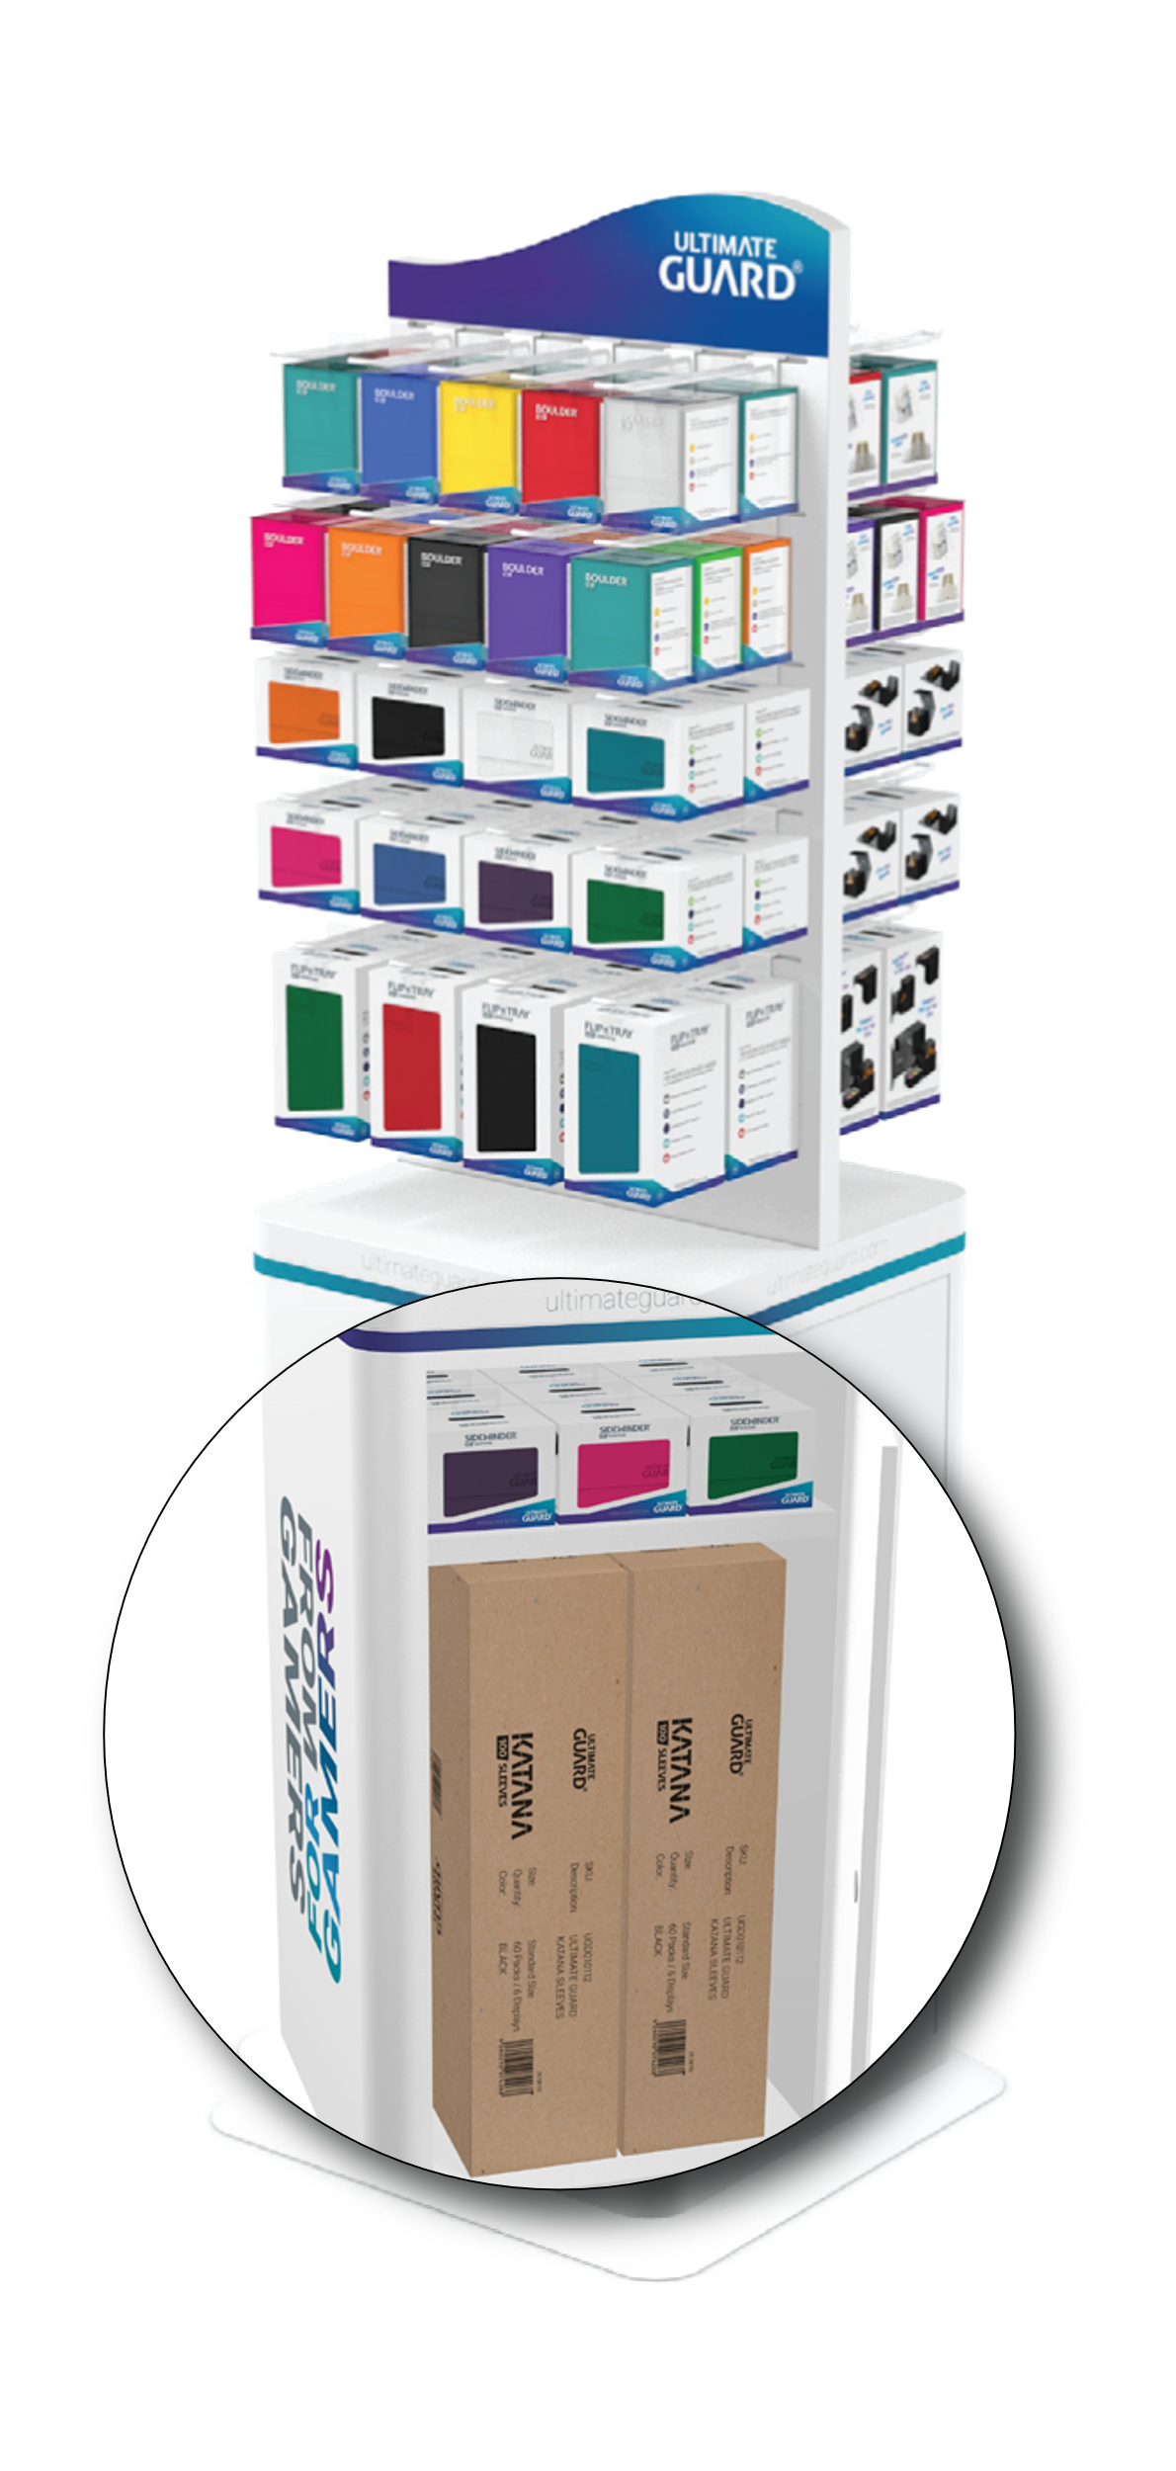
When a retailer inquires to a display, we will ask that you provide the retailer with 2 forms, the application form, and fill list.
- The retailer will need to fill out the application form and review the Fill List.
  - The Program requires $900 in net Ultimate Guard sleeve purchases to qualify. If the order contains non-sleeve items such as UG deck boxes, then the order must be $950 in net purchases to qualify and at least $470 of that purchase must be Katana Sleeves.
    - All Sleeves = $900
    - Mix = $950 *At least $470 must be sleeves*
- The distributor will fill the order from their own stock and send us confirmation.
  - All we will need as far as a confirmation from you is notification that the retailer met the fill requirement, the completed UGSD Application form. Once we receive confirmation, we will send the display from our warehouse to the retailer.

What Each Form Includes:

UGSD Application Form Contains
- The Application Form & Terms & Conditions- for selecting the display unit and filling out store details. This must be signed and dated by the retailer.
Ultimate Guard Floor Display Fill List
- 2 Recommended Fill lists are offered.
  - Mix – Both sleeves and deck boxes
  - All Sleeves- All Katana sleeves
- Substitutes can be made as long as the retailer meets the minimum dollar amount of $950 for a Mix of UG product (at least $470 of that being sleeves), or $900 for an order consisting only of UG sleeves.

